Mathematical Proposition

🌟 Definition
# Source: AI Source: Provided by: [Data Path: Persons Table -> ID Column: 1, Name_En Column: Motasem Essam] -> From: [ChatGPT] on [5/29/2026]
A mathematical proposition is a declarative statement in mathematics that can be either true or false. It expresses a clear claim and has a definite truth value.
In many cases, a proposition is a proven statement, but it is usually less important or less general than a theorem.

🎯 Purpose of a Proposition
# Source: AI Source: Provided by: [Data Path: Persons Table -> ID Column: 1, Name_En Column: Motasem Essam] -> From: [ChatGPT] on [5/29/2026]
- To state mathematical facts clearly
- To express results that can be proven true or false
- To build steps toward larger theorems
- To communicate logical mathematical statements
- To organize mathematical knowledge

📚 Key Characteristics
# Source: AI Source: Provided by: [Data Path: Persons Table -> ID Column: 1, Name_En Column: Motasem Essam] -> From: [ChatGPT] on [5/29/2026]
A mathematical proposition is:
- A complete statement (not a question or instruction)
- Either true or false (not both)
- Provable using logic and axioms
- Often simpler than a theorem
- Used in proofs of larger results

🧩 Structure of a Proposition
# Source: AI Source: Provided by: [Data Path: Persons Table -> ID Column: 1, Name_En Column: Motasem Essam] -> From: [ChatGPT] on [5/29/2026]
A proposition usually contains:
- A mathematical statement
- A condition or relation (sometimes)
- A truth value (true/false)
- A proof (if it is established as true)

✏️ Examples of Mathematical Propositions

Example 1
# Source: AI Source: Provided by: [Data Path: Persons Table -> ID Column: 1, Name_En Column: Motasem Essam] -> From: [ChatGPT] on [5/29/2026]
“5 is a prime number.”
✔ This is true.

Example 2
# Source: AI Source: Provided by: [Data Path: Persons Table -> ID Column: 1, Name_En Column: Motasem Essam] -> From: [ChatGPT] on [5/29/2026]
“The sum of two even numbers is even.”
✔ This is true and can be proven.

Example 3
# Source: AI Source: Provided by: [Data Path: Persons Table -> ID Column: 1, Name_En Column: Motasem Essam] -> From: [ChatGPT] on [5/29/2026]
“7 is greater than 10.”
❌ This is false.

Example 4 (Symbolic Form)
# Source: AI Source: Provided by: [Data Path: Persons Table -> ID Column: 1, Name_En Column: Motasem Essam] -> From: [ChatGPT] on [5/29/2026]
$$x+2=5$$
This is a proposition depending on the value of $x$.

🔗 Relationship to Other Concepts
# Source: AI Source: Provided by: [Data Path: Persons Table -> ID Column: 1, Name_En Column: Motasem Essam] -> From: [ChatGPT] on [5/29/2026]
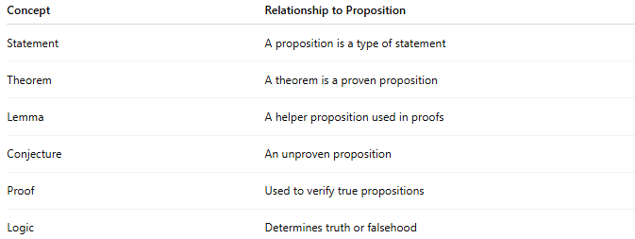
Concept | Relationship to Proposition
Statement | A proposition is a type of statement
Theorem | A theorem is a proven proposition
Lemma | A helper proposition used in proofs
Conjecture | An unproven proposition
Proof | Used to verify true propositions
Logic | Determines truth or falsehood

📖 Proposition vs Theorem vs Conjecture
# Source: AI Source: Provided by: [Data Path: Persons Table -> ID Column: 1, Name_En Column: Motasem Essam] -> From: [ChatGPT] on [5/29/2026]
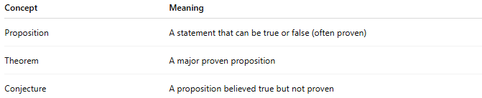
Concept | Meaning
Proposition | A statement that can be true or false (often proven)
Theorem | A major proven proposition
Conjecture | A proposition believed true but not proven

🧠 Simple Analogy
# Source: AI Source: Provided by: [Data Path: Persons Table -> ID Column: 1, Name_En Column: Motasem Essam] -> From: [ChatGPT] on [5/29/2026]
A mathematical proposition is like a claim in a debate:
- It states something clearly
- It can be judged true or false
- It may need proof or justification

🧭 Summary
# Source: AI Source: Provided by: [Data Path: Persons Table -> ID Column: 1, Name_En Column: Motasem Essam] -> From: [ChatGPT] on [5/29/2026]
A mathematical proposition is a clear statement in mathematics that is either true or false. If it is proven true, it may become a theorem. If it is not proven, it may remain a conjecture.

